**PROGRAMMING FUNDAMENTALS**

**PROJECT REPORT**

MINI PROJECT 1



|  |  |
| --- | --- |
| Group Members Name & Reg #: | **Muhammad Haris Irfan**  **(FA18-BCE-090)** |
|  |  |
| Class | Programming Fundamentals CSC103 (**BCE-2B**) |
| Instructor’s Name | Dr. Omer Ahmed |

**Mini Project 1: Maze Solving Game**

**Purpose**

To develop a Maze game without using Arrays, Pointers and user defined Functions. The details are as under: -

* The Game has a total of **9 rooms (**1 till Room 9).
* Each room has different Doors connected to different rooms, some doors are locked from one side and open from the other side and vice versa.
* Initially the user (player) is in **Room 1**, and his task is to find room 9 which is **Kitchen**, and finally come back to **Room 1** which is his room.
* The game **cannot end** without user visiting **Kitchen** at least once.

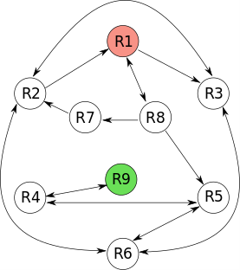

**Figure 1. Project Requirement Diagram**

**Project Description**

1. In this Project, **Switch/ Case, if / else** and **goto** Statements have been used. Whereas, for color and beep in-built functions have been used.

2. Separate Case has been made for each room; at the start of game the player is in **Room 1**, where he is given three choices (as per flow chart Figure 1) **Room 2**, **Room 3** and **Room 8**, if user chooses **Room 3 or 8,** he is jumped to **case 3** or **case 8** which represent our **Room 3** and **Room 8** respectively. Similarly, if the user selects **Room 2**, he is jumped back to the top of **Case 1** as the door of **Room 2** is locked from **Room 1**.

3. The game proceeds to the next level as per explanation given in Para 3 ante.

4. When the user reaches **Room 9** for the **1st time**, he receives a Congratulating message that he has reached it for the **1st time**; if he gets back into **Room 9** again, he will not be shown the congratulations message. Similarly, if the user comes back to **Room 1** without going to **Room 9 (Kitchen)**; the game does not end. Whereas, user has at to go to kitchen at least for once and then come back to his bedroom (**Room 1**) to win the game.

5. If else statements have been used to compare user entry, and goto statement inside if/else statements to jump between Cases i.e. separate case for each room. System Color Function for changing console color, beep function to add some sound when the user enters wrong number, the room is locked, the user gets into kitchen for the 1st time or and the end of the game.

**Working Program file is also inside the folder.**

**THE END**